**ASSIGNMENT-3(AP)**

**Name:** Yashvardhan Singh

**UID:** 22BCS10258

**Section:** 22BCS_FL_IOT-604

**Group:** A

**1) binary-tree-inorder-traversal**

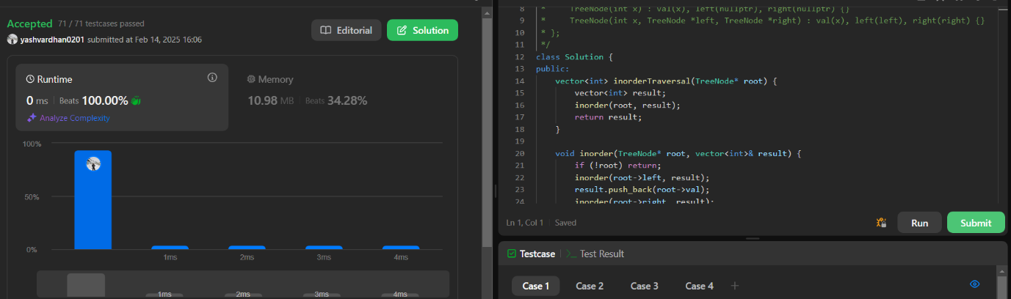

**2)** **symmetric-tree**

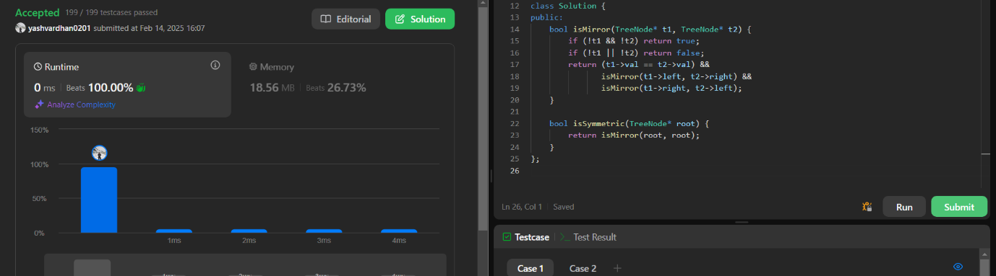

**3)** **maximum-depth-of-binary-tree**

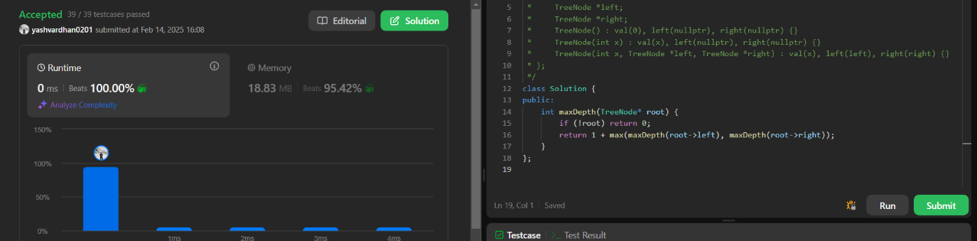

**4) validate-binary-search-tree**

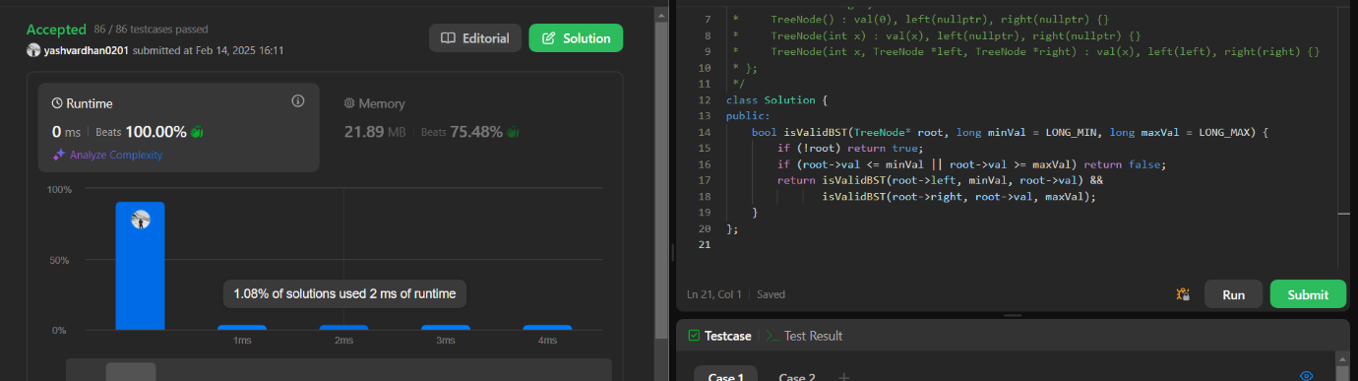

**5) kth-smallest-element-in-a-bst**

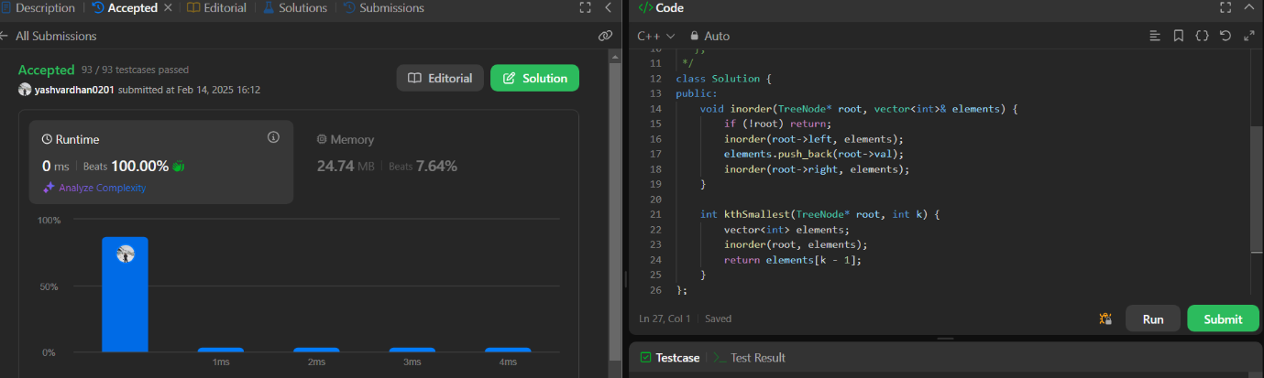

**6) binary-tree-level-order-traversal**

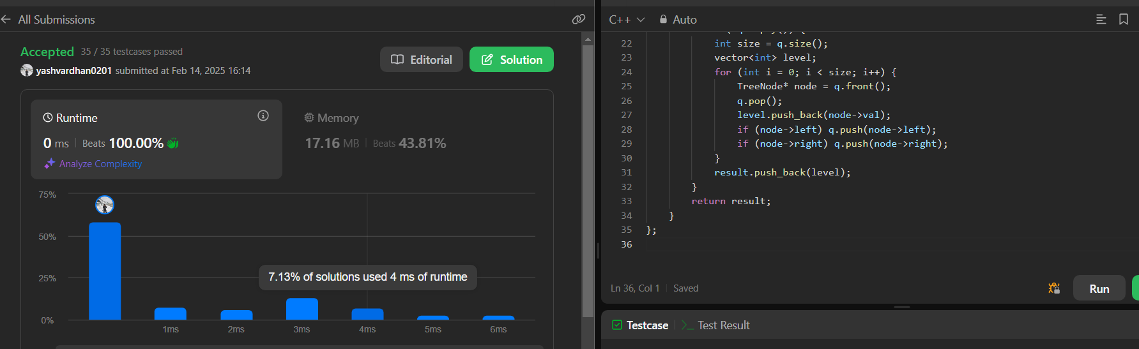

**7)** [**Binary Tree Level Order Traversal II**](https://leetcode.com/problems/binary-tree-level-order-traversal-ii/description/)

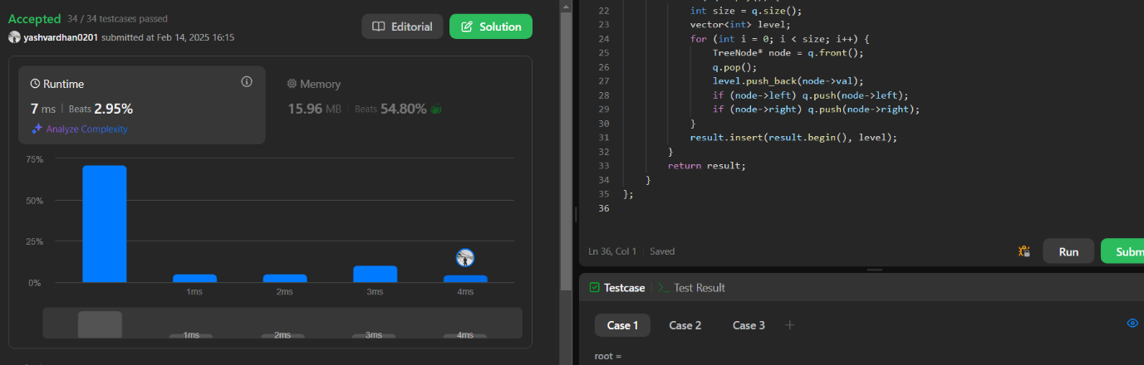

**8)** [**Binary Tree Zigzag Level Order Traversal**](https://leetcode.com/problems/binary-tree-zigzag-level-order-traversal/description/)

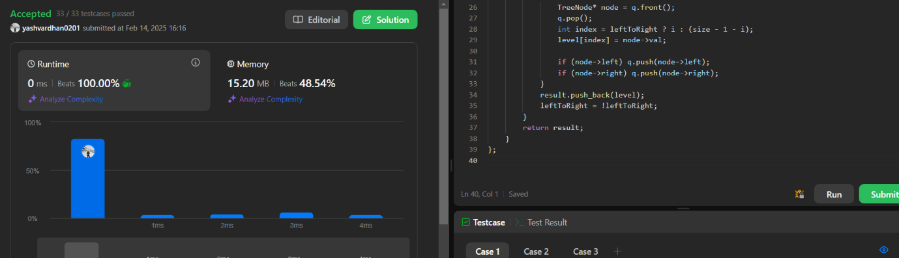

**9)** [**Binary Tree Right Side View**](https://leetcode.com/problems/binary-tree-right-side-view/description/)

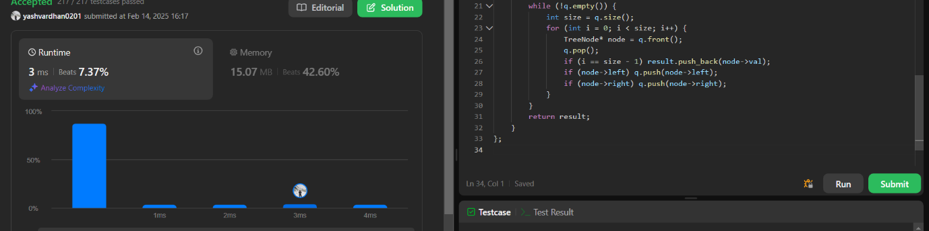

**10)** **.**[**Construct Binary Tree from Inorder and Postorder Traversal**](https://leetcode.com/problems/construct-binary-tree-from-inorder-and-postorder-traversal/description/)

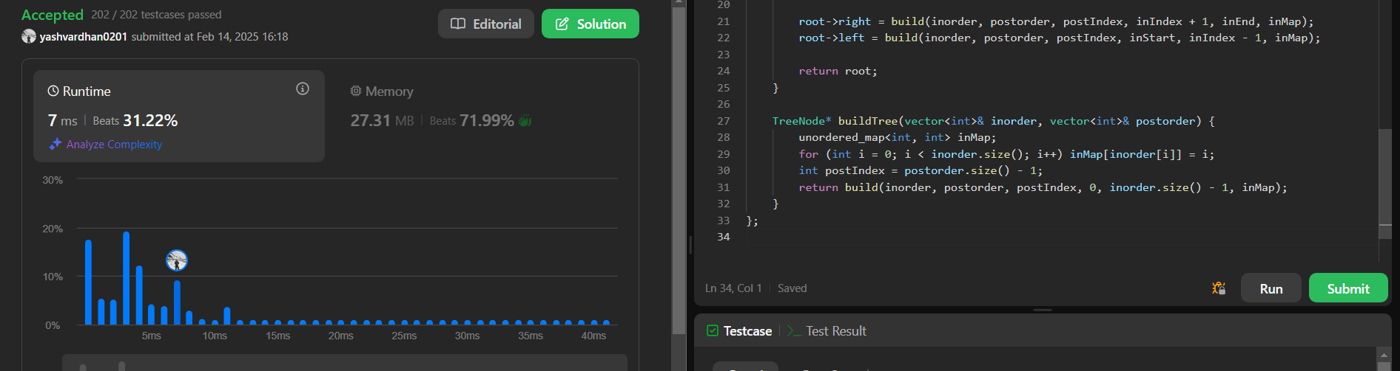

**11)** [**Find Bottom Left Tree Value**](https://leetcode.com/problems/find-bottom-left-tree-value/description/)

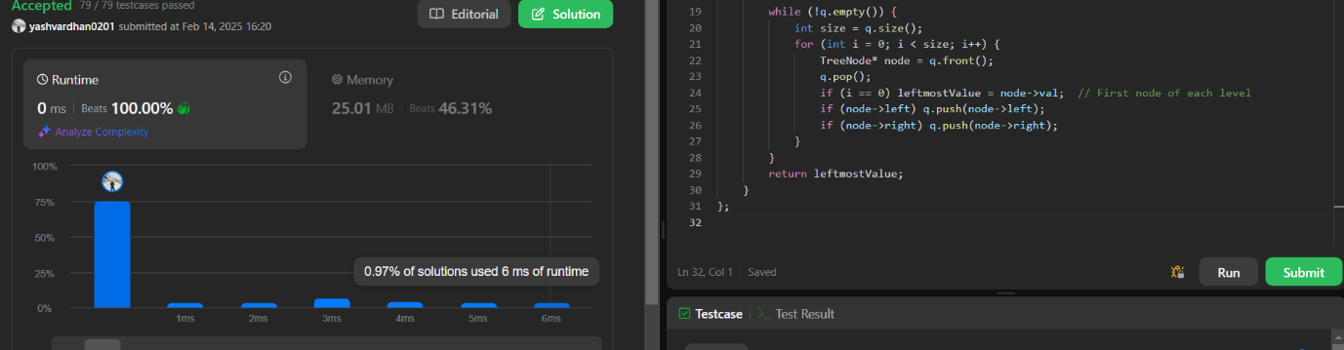

**12)** [**Binary Tree Maximum Path Sum**](https://leetcode.com/problems/binary-tree-maximum-path-sum/description/)

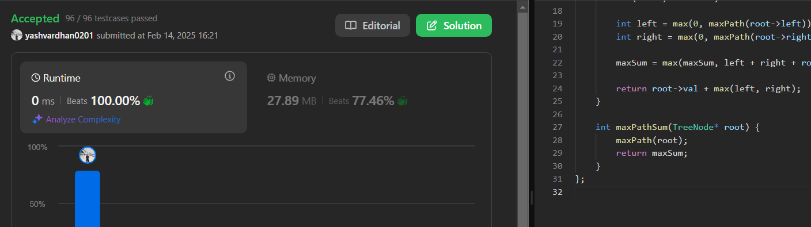

**13)** [**Vertical Order Traversal of a Binary Tree**](https://leetcode.com/problems/vertical-order-traversal-of-a-binary-tree/description/)

